A7Wc Welch’s ANOVA test

Welch’s ANOVA is an alternative to the traditional analysis of variance (ANOVA) and it offers some serious benefits. One-way analysis of variance determines whether differences between the means of at least three groups are statistically significant.

Welch’s ANOVA enters the discussion because it can help you get out of a tricky situation with an assumption. Like all statistical tests, one-way ANOVA has some assumptions. If you fail to satisfy the assumptions, you might not be able to trust the results. Simulation studies have been crucial in revealing which assumptions are strict requirements and which are more lenient.

The Classic one-way test assumes that all groups share a common standard deviation (or variance) even when their means are different. Unfortunately, simulation studies find that this assumption is a strict requirement. If your groups have unequal variances, your results can be incorrect if you use the classic test. On the other hand, Welch’s ANOVA isn’t sensitive to unequal variances.

Welch’s ANOVA test

If F is defined as follows:

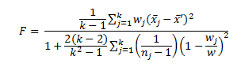

where

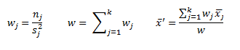

then

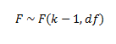

where

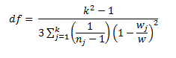

Hypothesis statement

Null hypothesis H₀: population means equal

Alternative hypothesis H₁: at least one of the population means not equal

Example

A drug company created a small trial of an antiseptic cream for skin scratches. It measured the effectiveness of the new cream compared to the leading cream on the market and a placebo. Thirty people were put into three groups of 10 at random, although just before the trial began 2 people from the control group and 1 person from the test group for the existing cream dropped out.

New | Old | Control
50 | 44 | 16
39 | 31 | 60
42 | 50 | 24
45 | 22 | 19
38 | 30 | 31
44 | 27 | 37
40 | 32 | 44
49 | 25 | 55
42 | 40
41
Table 1

Test the hypothesis that the cream has no effect at a 5% significance level.

Calculate summary statistics

We see from row 21 of Figure 1 that the variances of the three groups are 16.2, 86.5 and 265.6, and so we suspect there is a significant difference between the variances. You could confirm this by conducting Levene’s test where the p-value = 0.005478.

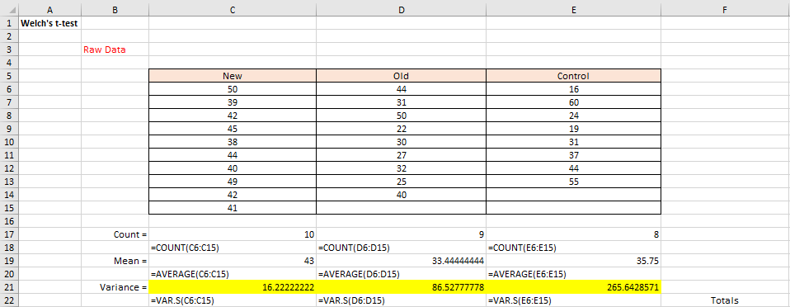
Figure 1

Welch solution

Thus, the normal one-way ANOVA is not the correct test to use.

We employ Welch’s ANOVA test instead, as shown.

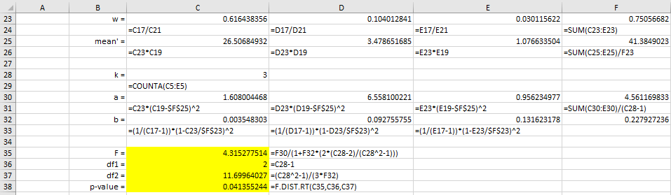
Figure 2

We see from Figure 2 that the p-value = 0.041355 < 0.05 = α, and so we conclude that there is a significant difference between the means of the three groups.

One-way ANOVA solution

Note that if we had used ANOVA, we would have come to a completely different conclusion (since p-value = 0.14 > 0.05 = α).

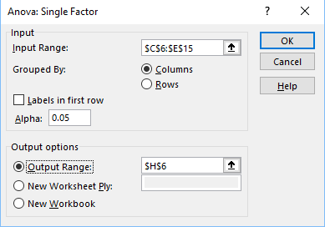
Figure 3

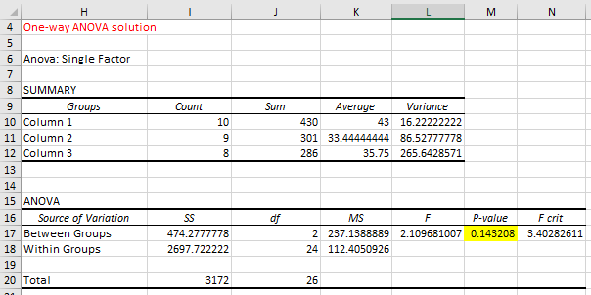
Figure 4

